PROJECT DEVELOPMENT PHASE SPRINT-1 TEST CASES

|  |  |
| --- | --- |
| Date | 1 November 2022 |
| Team ID | PNT2022TMID47002 |
| Project Name | Intelligent vehicle damage assessment & cost estimator for insurance  companies. |
| Maximum Marks | 8 Marks |

Login Page

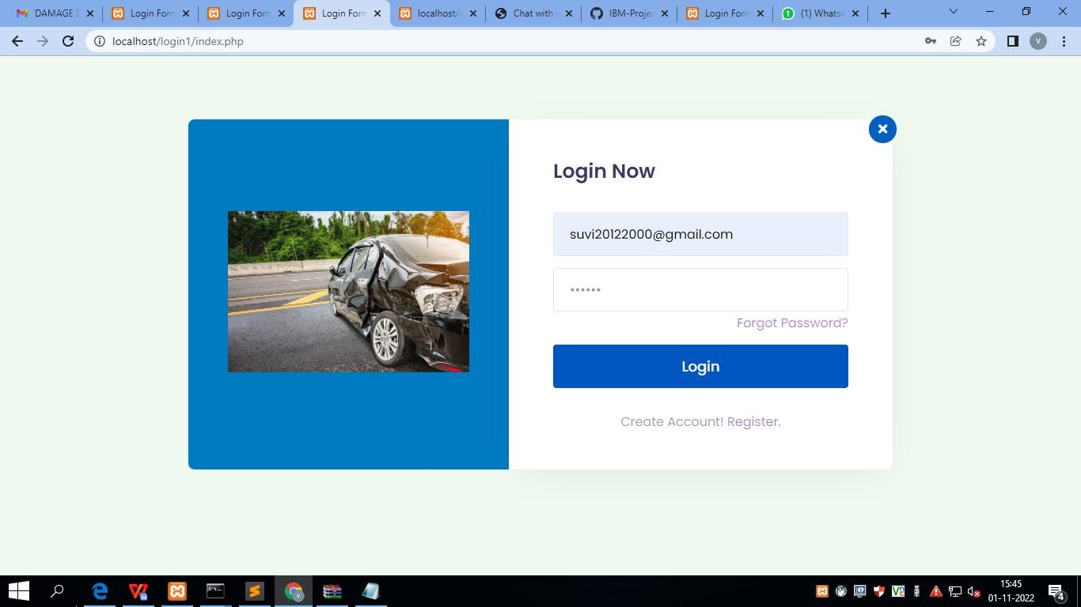

Register Page

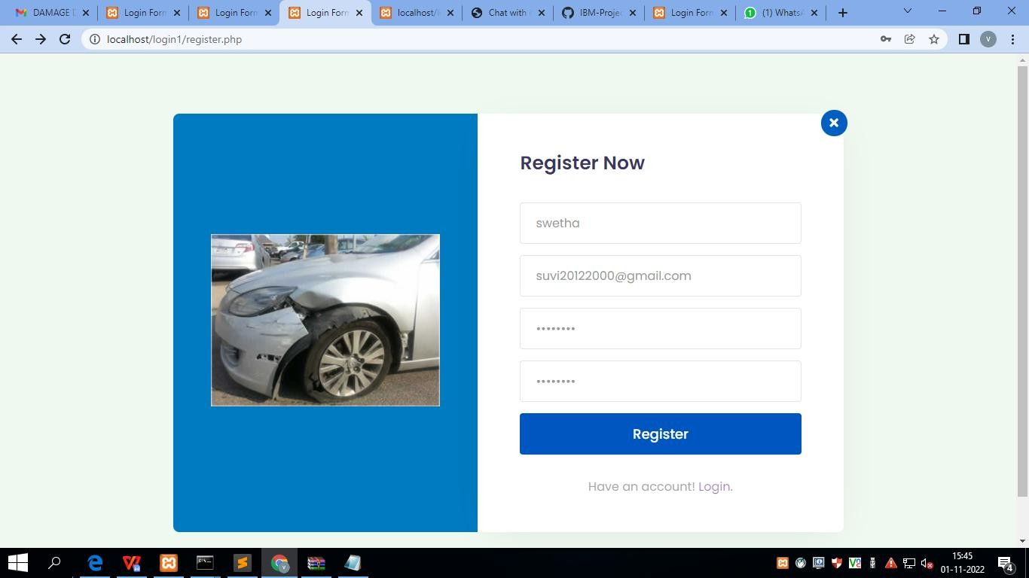

User Confirmation

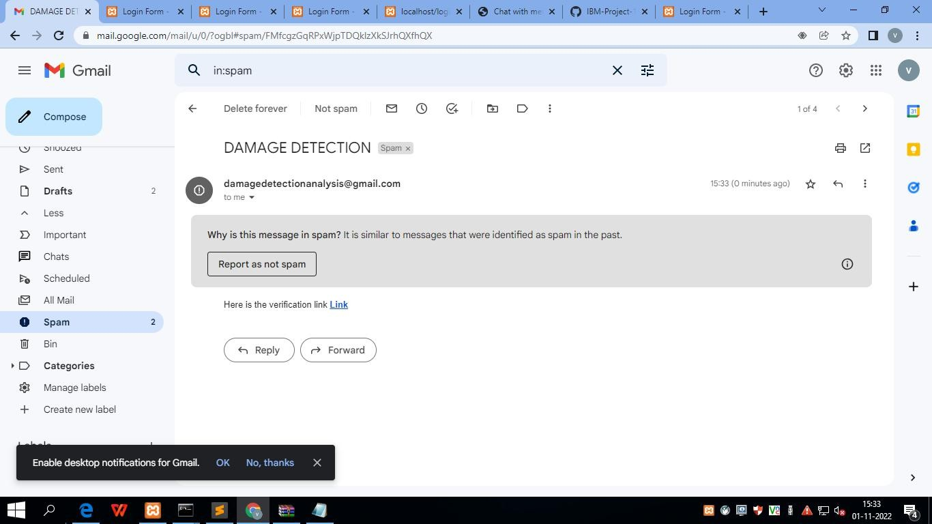

Forgot Password

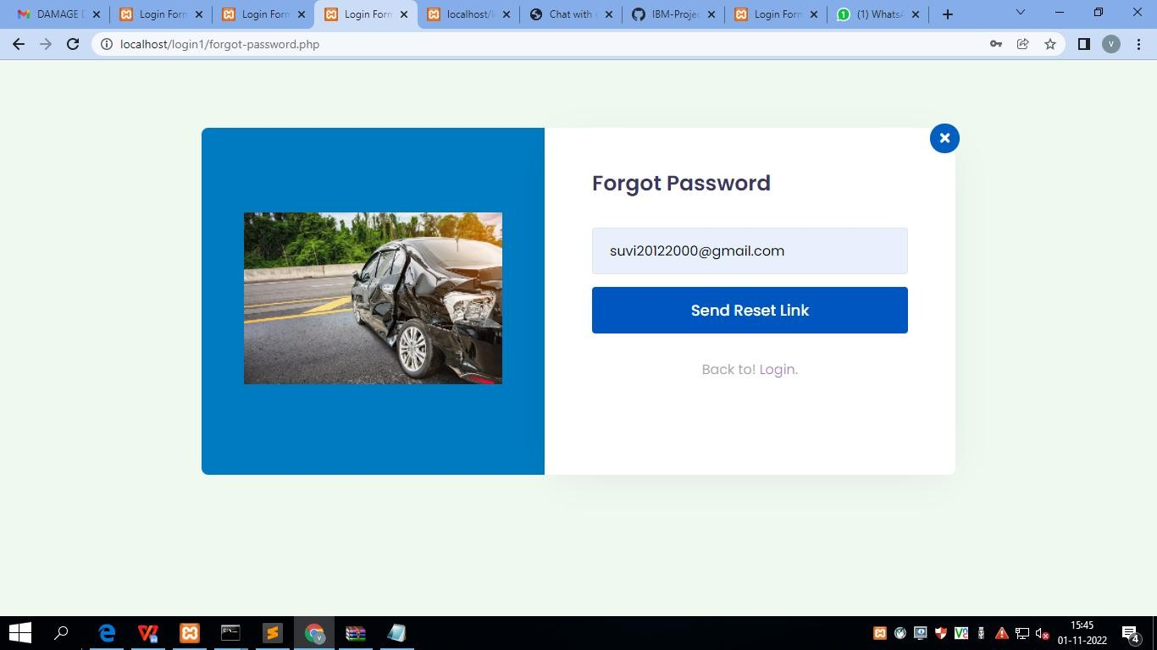

Reset Password

